*Yong Son*

*Nov 21, 2020*

*IT FDN 110 A Au20: Foundations of Programming: Python*

*Assignment 06*

**Modify To-Do list scripts using**

**Calss, Function, parameters and Arguments**

Introduction

Last week, I’ve learned how to divide entire scripts into three major sections of code: Data, Processing, and Presentations. This week, scripts are divided into Data, Processing, I/O and Main Body using Classes and Functions.

Function and Class

Function is a block of code that can be run for specific tasks. Programmer can break down the scripts into small pieces of tasks and each specific task defines a function. Programmer must define a function for specific purposes and call function to execute the statements in the function. Parameters and arguments can carry values into the function to process the statements. Classes are used to group multiple functions under same category such as processing and I/O.

When using Classes and functions in the script, order of the script may cause confusion to some programmers. Most people feel comfort when the instruction of the code goes from top to bottom. However, using functions and classes will ask the programmer to jump from one section of the script to other section. This confusion caused by calling and defining functions can be resolve by using debug option in Pycharm. Pycharm’s debugging option can help the program to location next line of code when each function is processed.

Homework assignment 06

Assignment 06 performs similar tasks as assignment 05. Both assignments ask the programmer to write a script that reads the text file from the hard drive and import the data into program and display it. And if the user wants to add or delete any items in the data, program can performs the task and save the data back to the text file. Assignment 06 is more focused to define each instruction of tasks to each function and call these functions to perform the task on the main body of the script.

Modification of Assignment 06 scripts

First thing I do before defining each function is to create a “test.py”. Using test file is very useful when programming multiple functions in a same script. I can simplify the script to run one function at a time and check the performance and result. Also debugging process is much easier since I do not have to jump back and forth between each class. (Figure 6-1)

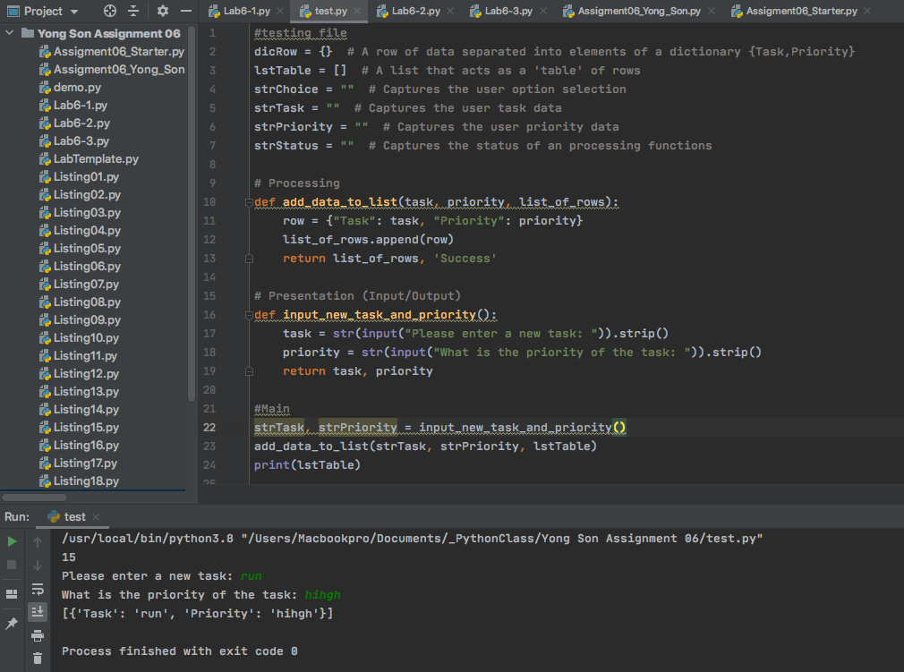

***Figure 6-1: Testing each functions using test file***

Each menu choices require at least two main functions. At least one function is needed for I/O instruction and other one to process the task.

For Menu choice 1: add a new task. This task required me to revise “input_new_task_and_priority()” function and “add_data_to_list()” function. Ask you can see from Figure 6-1, “input_new_task_and_prority()” only performs one job, asking input and return those input values. These input values then will be save in strTask and strPrioity and called into “add_data_to_list()” function. On “add_data_to_list” I used append command to add strTask and strPriority values to lstTable. (Figure 6-1)

For Menu choice 2: remove an existing task. This task also uses similar input function called “input_task_to_remove()”. This function only asks for one input value, which is a Task (Figure 6-3). Then “remove_data_from_list()” function should be called to delete specific Task input by the user (Figure 6-3). “remove_data_from_list()” uses a for loop to compare input value with tasks saved in lstTable (Figure 6-2).

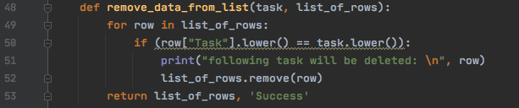

***Figure 6-2: For loop to compare task values and if “TRUE”, delete the row***

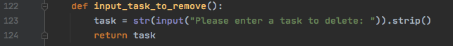

***Figure 6-3: Asking for input and return the task value***

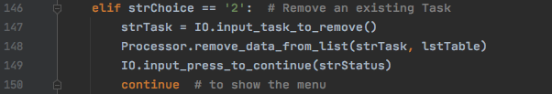

***Figure 6-4: Performs menu choice 2: remove specific task input by user***

For Menu choice 3, save data to text file. Before save the data back into the text file, program will ask the user for a confirmation (Figure 6-7) and display current tasks in the list (Figure 6-6). If the user enters “y”, program will perform “print_current_Tasks_in_list()” function to display all data before it gets save into the text file (Figure 6-6). Then “write_data_to_file()” function will use to for loop to go through each row of the table and start writing each tasks and priorities into the text file (Figure 6-5).

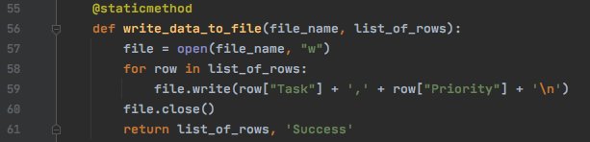

***Figure 6-5: write data into text file***

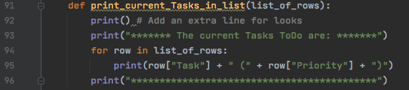

***Figure 6-6: Display current tasks in the list***

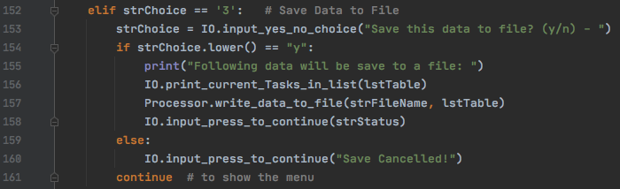

***Figure 6-7: Using if statement to save data into text file or cancel the task***

For Menu choice 4, reload data from file. This task will delete all unsaved data and refresh the lstTable with new data from text file (Figure 6-10). “read_data_from_file()” function is pre-defined in homework assignment. It clears the memory on the lstTable and reloads the data from text file using “for loop”. “For loop” reads each line and import Tasks and Priorities from each line and save it into the lstTable (Figure 6-8). After program reloads the new data from text file, it will display it on the screen (Figure 6-9).

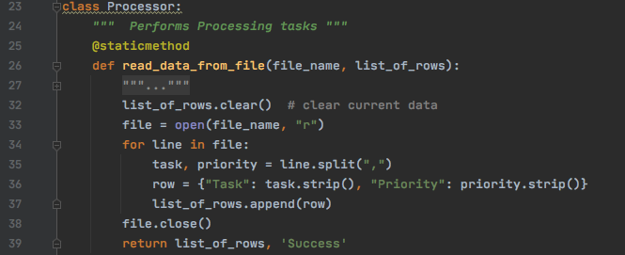

***Figure 6-8: Read data from text file***

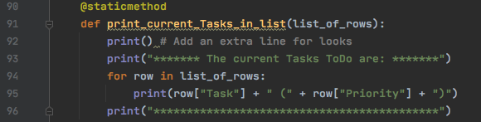

***Figure 6-9: Display current tasks in the list***

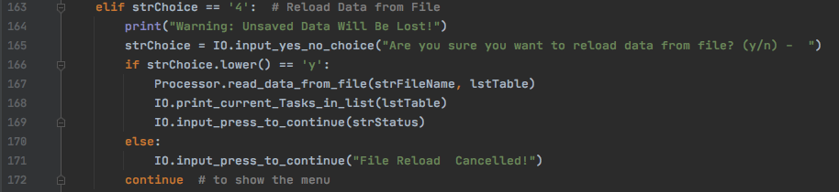

***Figure 6-10: Reload data from the file and display it on the screen.***

For Menu choice 5, exit out task if not require any revision on the code.

Result showing in Pycharm:

/usr/local/bin/python3.8 "/Users/Macbookpro/Documents/_PythonClass/Yong Son Assignment 06/Assigment06_Yong_Son.py"

******* The current Tasks ToDo are: *******

update starter code (high)

write about the how I did it (high)

upload to new GitHub repository (high)

create repository web page (high)

submit to Canvas (high)

Finish homework (High)

*******************************************

Menu of Options

1) Add a new Task

2) Remove an existing Task

3) Save Data to File

4) Reload Data from File

5) Exit Program

Which option would you like to perform? [1 to 5] - 1

Please enter a new task: Upload HW assignment

What is the priority of the task: High

******* The current Tasks ToDo are: *******

update starter code (high)

write about the how I did it (high)

upload to new GitHub repository (high)

create repository web page (high)

submit to Canvas (high)

Finish homework (High)

Upload HW assignment (High)

*******************************************

Press the [Enter] key to continue.

******* The current Tasks ToDo are: *******

update starter code (high)

write about the how I did it (high)

upload to new GitHub repository (high)

create repository web page (high)

submit to Canvas (high)

Finish homework (High)

Upload HW assignment (High)

*******************************************

Menu of Options

1) Add a new Task

2) Remove an existing Task

3) Save Data to File

4) Reload Data from File

5) Exit Program

Which option would you like to perform? [1 to 5] - 2

Please enter a task to delete: Finish homework

following task will be deleted:

{'Task': 'Finish homework', 'Priority': 'High'}

Press the [Enter] key to continue.

******* The current Tasks ToDo are: *******

update starter code (high)

write about the how I did it (high)

upload to new GitHub repository (high)

create repository web page (high)

submit to Canvas (high)

Upload HW assignment (High)

*******************************************

Menu of Options

1) Add a new Task

2) Remove an existing Task

3) Save Data to File

4) Reload Data from File

5) Exit Program

Which option would you like to perform? [1 to 5] - 3

Save this data to file? (y/n) - y

Following data will be save to a file:

******* The current Tasks ToDo are: *******

update starter code (high)

write about the how I did it (high)

upload to new GitHub repository (high)

create repository web page (high)

submit to Canvas (high)

Upload HW assignment (High)

*******************************************

Press the [Enter] key to continue.

******* The current Tasks ToDo are: *******

update starter code (high)

write about the how I did it (high)

upload to new GitHub repository (high)

create repository web page (high)

submit to Canvas (high)

Upload HW assignment (High)

*******************************************

Menu of Options

1) Add a new Task

2) Remove an existing Task

3) Save Data to File

4) Reload Data from File

5) Exit Program

Which option would you like to perform? [1 to 5] - 4

Warning: Unsaved Data Will Be Lost!

Are you sure you want to reload data from file? (y/n) - y

******* The current Tasks ToDo are: *******

update starter code (high)

write about the how I did it (high)

upload to new GitHub repository (high)

create repository web page (high)

submit to Canvas (high)

Upload HW assignment (High)

*******************************************

Press the [Enter] key to continue.

******* The current Tasks ToDo are: *******

update starter code (high)

write about the how I did it (high)

upload to new GitHub repository (high)

create repository web page (high)

submit to Canvas (high)

Upload HW assignment (High)

*******************************************

Menu of Options

1) Add a new Task

2) Remove an existing Task

3) Save Data to File

4) Reload Data from File

5) Exit Program

Which option would you like to perform? [1 to 5] - 5

Goodbye!

Process finished with exit code 0

Result showing in Terminal:

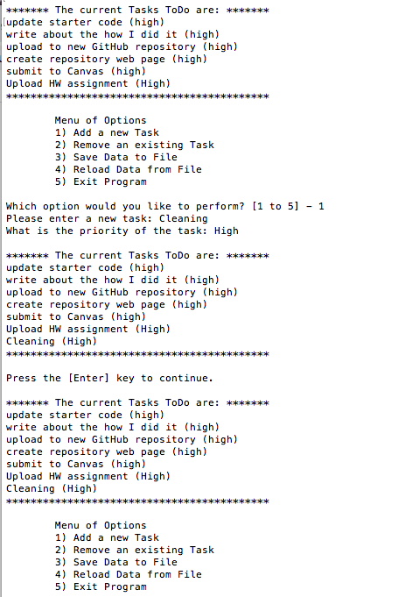

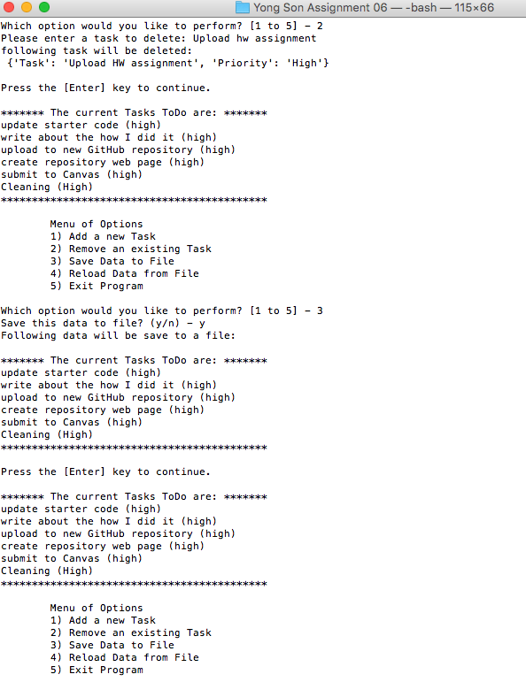

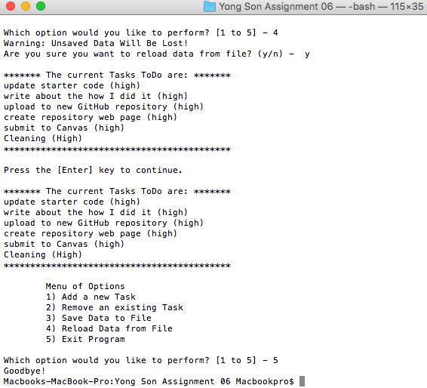

To-Do text File

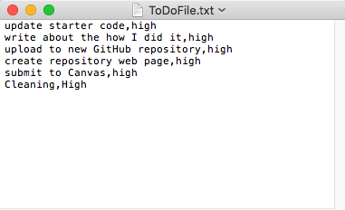

Conclusion

In this assignment, I’ve learned about Classes and Functions. Writing a script using Classes and Functions bring lots of benefits. Each functions can be reused with simply line of code and Classes can group these functions into one place so we can easily find each functions by its categories.